Cultural nomadism
In search of the sources of the “sellotape selfie”

Mario Savini

A “sellotape selfie” is the sharing of a self-portrait depicting one’s face previously deformed and shaped by applying some sellotape on it. This phenomenon began to virally spread through Facebook in Spring 2014. What it is exalted is a no longer defined figure, the passage of a process which becomes metaphor of the steady flux of life. The “sellotape selfie”, in fact, witnesses the search for a further definition of one’s identity that one can try to change fast and in a way that one thinks proper. It is an aesthetic practice which perfectly fits the debate on the post-human condition for it witnesses the reconsideration of subjectivity, of man’s transformations and of life. In reference to the researchers of some contemporary artists, it is possible to widen the reflection on concepts of mobility and nomadism in the globalization era. With the spreading of new technologies and of the web, it is unthinkable nowadays, to oppose art to non-art, since the artwork has managed to widen the borders of its representation to immerse in the experience of life. The artist’s activity overlies the one of the audience underlining the surfaces of cultural nomadism and embodying the meaning of generalized precariousness.

A “selfie” is «A photograph that one has taken of oneself, typically one taken with a smartphone or webcam and uploaded to a social media website». This neologism has been the word of 2013 in the Oxford Dictionaries. The fast and widespread circulation of this phenomenon has followed the rapid increasing of mobile phones, particularly of smartphones which have begun implementing the front-facing camera. The “selfie” is a social behavior typical of our era called “hybrid era” by Ayesha and Parag Khanna (2013), a socio-technological age characterized by technologies merging with human beings. The mobile phone, after all, is a very important part of our life for it is an item we always take with us and with which we form an intimate bond; it even can make us more prone to new pathologies such as nomophobia or the uncontrolled fear of not having our smartphone with us and thus of being disconnected from the net. The technological item is becoming more and more an ‘object parlant’, having its own soul; a model which can be traced back to ancient Egypt where each item spoke for the Gods. The “selfie” also constitutes an aesthetic practice of undisputed cultural value for its ability to witness the daily events with great rapidity. Strictly connected to it, it is another particular phenomenon called “sellotape selfie” or “sellofie”, that is the imaginary representation of one’s physical aspect, the sharing of a self-portrait depicting one’s face previously deformed and shaped by applying some sellotape on it. These pictures seem to have abandoned the usual reading codes and narrate a transformation through irony, game and exaggeration as if the protagonist was immersed in border lands where losing one’s identity is very easy. This new way of describing oneself, which takes its name from the well-known English sellotape brand, began to virally spread from the United Kingdom and through Facebook in Spring 2014. A twenty-one-year female student at the Brighton University had been inspired by a scene of the comedy Yes Man (2008) directed by Peyton Reed, where the actor Jim Carrey disfigured his face using the sellotape.

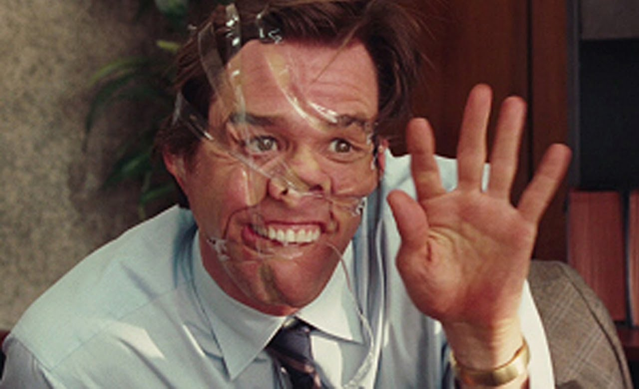
Peyton Reed, Yes Man, 2008
What these actions, often unsettling and weird, want to underline is the unrecognizable appearance of the subjects; they want to show mutant corps or, in Massimo Cacciari’s words, «wimp» corps (2004). It also represents an invitation to revaluate transgression among the new forms of thinking activities, thus in the current declarations of existence. What it is exalted is a no longer defined figure, the passage of a process which becomes palpable metaphor of the steady flux of life. As stated by Henry Jenkins in his famous essay Convergence culture, this means that «we are living the birth of new narrative structures which become more and more complex through the widening of the range of the possibilities of storytelling; they no longer trace a straight path made of a beginning, a center and an end» (Jenkins 2007: 111). The “sellotape selfie”, in fact, witnesses the search for a further definition of one’s identity that one can try to change fast and in the way that one thinks proper. It thus represents another step into the daily performative practices which have been preceded by the well-known photographic sneering self-portrait by Fortunato Depero dating back to 1915. The “sellofie” is certainly a widening of the debate on the new concept of humanity which was begun by Jeffrey Deitch in June 1992 through his traveling exhibit called Post Human, launched for the first time at the FAE Musée d’Art Contemporain in Pully-Losanna. Plastic surgery and genetic manipulation are widespread practices by now and have undoubtedly contributed to the radical transformation of the definition of corporality:

Our consciousness of the self will have to undergo a profound change as we continue to embrace the transforming advances in biological and communications technologies. […] As radical plastic surgery computer-chip brain implants and gene-splicing become routine, the former structure of self will no longer correspond to the new structure of the body. A new post-human organization of personality will develop that reflects peoples’ adaptation to this new technology and its socioeconomic effects. […] Reality, fantasy and fiction are merging into the inspiration for a new model of personality organization (Deitch 1992).
I think that the “sellotape selfie” perfectly fits, in a creative and critical way, the debate on the post-human condition, for it testifies the reconsideration of subjectivity, of the transformations of what is human and of life. It must be noted that this phenomenon began to spread when Rosi Braidotti (2014) started to deepen the topics related to the crisis of the concept of human and to the extraordinary power of new technologies. These two positions seem to converge when the discussions on the nature of the artistic object are developed in the essay The Posthuman:

By taking us beyond the borders of obliged identities, art becomes necessarily inhuman or not human, for it ties up with the plant-animal, material and planetary forces surrounding us. Additionally, art is cosmic for its own resonance and thus has a post-human structure as it takes us to the limits of what our incarnated selves can do and bear. As long as art stretches the borders of representation, it reaches the limits of life and faces the horizon of death. From this point of view, art is linked to death meant as a limit experience (Braidotti 2014:115).

Regarding the issues connected with the dehumanization of the subject, it is important to linger on the artistic research by Douglas Gordon. Through video-making, photography and installation, the Scottish artist inspects and elaborates the issues linked to the concepts of identity, self-representation and to the relation between opposite concepts (such as life and death, good and evil, fear and temptation), by suggesting to reflect on the transition states and on the post-identity topics. His repertoire is based on the images of the cinema classics and of Christian iconography which are impressed in the collective memory. Particularly, the work Monster Reborn (1996/2002), even before the movie Yes Man, is a very interesting anticipation of the “sellotape selfie”.

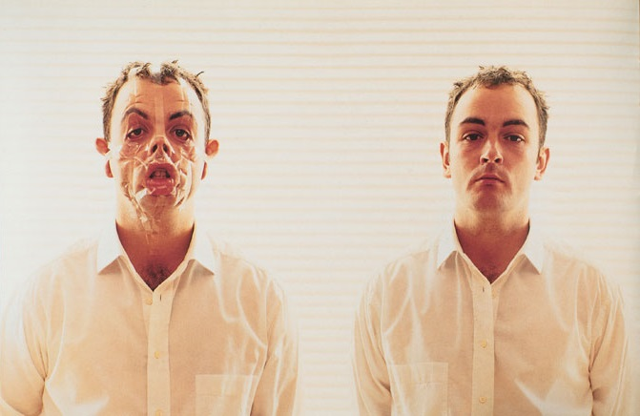
Douglas Gordon, Monster Reborn, 1996-2002

The double self-portrait on a cold and anonymous background sets a parallel between the natural representation of the subject and the discussion on its features through the deformation of the face caused by the transparent sellotape. The distortion of facial features and the title of the work shift the attention on the double personality of the protagonist in an ironic way so as to lighten the severity of the message. Douglas Gordon underlines the charm of ambiguity by making its face only partially recognizable and involves the notion of time by recalling the transitory character of human nature. The meaning of this work seems to be linked to the story of the very famous novel of Robert Louis Stevenson, also from Scotland. The strange case of Dr. Jekyll and Mr Hide (1886) is a fundamental point in the North-European literature of the XIX century for it is an involving investigation into the human psyche and on the split personality. Here the metaphor is on the fight between good and evil and life and death as well.
Between 1995 and 1996, the English painter Jenny Saville began to collaborate with the photographer and filmmaker Glen Luchford. She had him take a picture of her while her body was pressed against a transparent Perspex sheet. This gave birth to the Closed Contact series, that is a series of pictures depicting from the bottom a body horribly deformed and no longer recognizable.

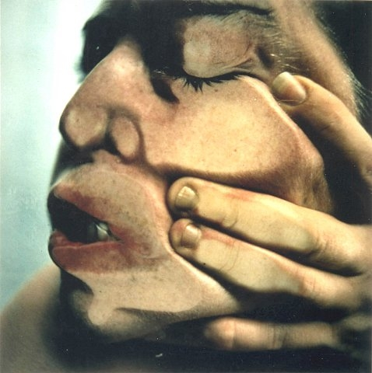
Jenny Saville & Glen Luchford, Closed Contact #14, 1995-1996
In 1994, after assisting to some plastic surgeries in a New York City clinic, Jenny Saville began to focus her attention on the power technologies have to transform the human body, suggesting an aesthetic ideal which was opposed to that of contemporary trends. Heaps of truculent flesh explore the charm of deformity through an awkward presence. Lines resemble wounds and seem to liquefy into a borderless material. These works invite everyone to reflect on the steady search for human body perfection which is a basic feature of our time. After all, as stated by Zygmunt Bauman,

[…] everyone is a user in a society of users. The consumer society is a market society: we are all in and on the market, users and goods at the same time. It is normal that the use/deterioration of human relationships and thus, consequently, of our identities as well (for we identify in reference to the people with whom we have relationships) resemble more and more the use/deterioration of cars, just like that cycle beginning by buying a good and finishing by throwing it away (Bauman 2010: 89).

In Closed Contact by Jenny Saville and in Monster Reborn by Douglas Gordon – both dating back to the same period – the skin of the depicted subjects is stretched and manipulated by outer forces in order to expose the unpleasant expression of the subject. As stated by Francesca Alfano Miglietti, it is true that «the body which is not afraid of manifesting its own diversity is the body which includes all of the meanings of social discourse, of what we are as a cultural organism and of the way codes, norms, fears and hopes are introjected» (Alfano Miglietti 2001: 110). It is very important to note that in the same period, particularly in 1994, the sheep Dolly was cloned, an event which amplified, especially from a philosophical and ethical point of view, the debate on the post-human and on the way the border between natural and artificial life are conceived. Today, the “sellotape selfie” phenomenon is becoming the global monument – stimulated by the net – of viscosity, of generalized precariousness and of death, as conceived by Rosi Braidotti and as expressed by the work of the American Wes Naman.
In 2013 the artist created a series of pictures entitled Scotch Tape showing different people with faces deformed by transparent sellotape.

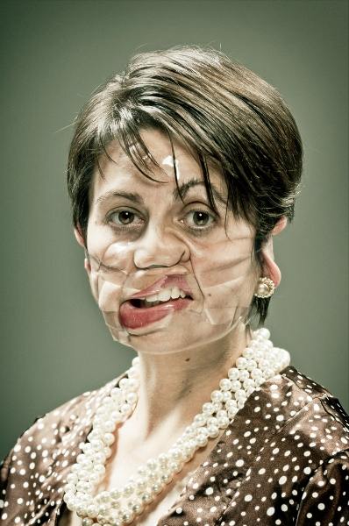
Wes Naman, Scotch Tape, 2013
The idea had been developed in 2012 when Naman was in his office packing some Christmas presents with his assistant Joy Godfrey who, for a moment, applied some scotch on his face. The protagonists of Naman’s pictures, funny and shocking at the same time, include different types of practitioners, ranging from career women, employees, motorcyclists and celebrities, all of them depicted on a monochrome background. His pictures, always a bit provocative, recall the characteristics of the photo series Rubber band (2013) by the same artist, describing people with faces modified through elastic bands. Also in this case, the photo background does not distract people since their attention is totally on the represented subject, giving to the spectator the sensation to be in front of an artificial identity and underlining its transience. The distortion of the face is, in fact, transitory; it just takes the time of a click, letting others reflect on the concept of mobility or nomadism in the era of globalization. These aspects, in particular, are in accordance with what Nicolas Bourriaud had anticipated in 2009 when referring to the permanent changes of people in a radicant universe tracing a joining line with the theories by Zygmunt Bauman on the precariousness of human existence:

Among the sociological phenomena of the beginning of the XXI century, the generalization of disposable goods is among the most unnoticed […]. But the average life of any item is shorter and shorter, commercial rotation is getting faster and faster, obsolescence is accurately planned. Social life is very fragile and fragile are the ties which it is made of. The agreements ruling the work market only reflect this general precariousness, traced on that goods whose rapid expiration is embedded in our perception of the world […]. It is impossible not to note that by now everyone intuitively feel existence as a whole made of ephemeral identities […]. In a surrounding environment always modernized and reformatted where the transitory replace the long-term and the right to access propriety, the stability of things, signs and states become the exception (Bourriaud 2014: 81-81).

This last concept is well expressed in the photo series Blow Job (2012) by Tadas Černiauskas (aka Tadao Cern).

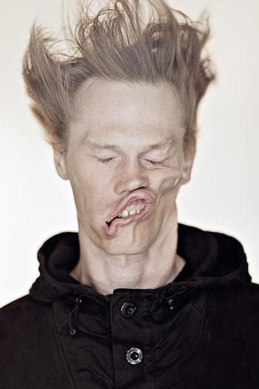
Tadao Cern, Blow Job, 2012

This artist from Lithuania depicts some people deforming their features through blasts of air: identity becomes a vacant point which becomes horrible fantasy no longer capable of defining the idea of stability. Facial expressions are completely unnatural and seem to be unfinished plasticine sculptures o wax busts deformed by the heat. On the Facebook page of the artist there is an album showing the faces of protagonists before and after being deformed by the force of the blasts of air. The comparison between the different pictures shows the diversity of the body due to the incontrollable and violent force produced by a machine (the symbol of technology); it is a twisting which recalls the work by Douglas Gordon, or even, the image of the two-faced Janus, the one who better expresses the man of the hybrid age, his doubleness and his being alone but active in his online community at the same time. The work by Tadao Cern, thus, seems a perfect metaphor of the transparent speed - just like a blast of air – with which today we witness the melting of contemporary cultures and the several stimulations that are offered to us.
All of the works described by now are based on the artistic research by the French Orlan who, since the beginning of the 90’, has modeled her face by undergoing a series of plastic surgeries, since she considered the operation room to be a real artistic atelier. Her facial transformations occur in a conscious and not anesthetized body, completely awake during its own metamorphosis. Some of her surgery performances have been broadcasted live at the same time both via satellite and in several museums in order to let the artist have the opportunity to answer to the questions of the audience. Carnal art, as stated by Orlan,

[…] is a classic self-portrait but realized through the technological means of her time. It fluctuates between de-figuration and re-figuration. The artwork can be cut into the skin since allowed by our age. The body becomes a “modified ready-made” since the ideal ready-made to be signed does not exist anymore. In contrast with Body Art, Carnal Art does not want any pain, nor this is looked for as a source of purification or Redemption. Carnal Art is not interested in the final sculptural result, but in surgery-performance and in the modified body which becomes a place of public debate (Orlan 1996: 30).

With the spreading of new technologies and of the web, opposing art to non-art is very difficult or even unthinkable today, since the artwork has managed to widen the borders of its own representation in order to immerse in the experience of life. When an artistic research overlies the dynamics of social phenomena emphasizing the process and considering the artwork as a place of transaction, it is very difficult to distinguish the border dividing the artist’s activity and that of the audience. In his book Postproduction, Nicolas Bourriaud had already lingered on this aspect by offering a critical reading of the work Untitled (One revolution per minute) by Rirkrit Tiravanija:

[…] a kiosk selling crêpes to visitors is at the center of a labyrinth of benches, catalogues and tents; pictures and sculptures dating back to the 80’ […] emphasized the space. Since the artwork fundamentally consists in the serving of a dish and the spectators are encouraged to perform daily activities, where does cooking end and where does art begin? This clearly demonstrates the will to invent innovative links between artistic activity and the combination of man’s activities by building a narrative space which captures daily purposes and structures in a form-scenario as different from traditional art as the rave-party is from the rock concert (Bourriaud 2004: 45).

Today this determination to create innovative links between artistic activity and man’s activity seems to have found its solution, for example, in the “selfie”, which is an action capable of reinforcing its own resonance through the web. The “sellotape selfie” shows that the initiative of an English college student spread through the social network and the artistic research by Wes Naman move on an identical socio-cultural level as well as the operating room used by Orlan, the kiosk employed by Rirkrit Tiravanija and the social network (vital focus of the selfie) which replace conceptually and physically the traditional expository space. Artwork as well as identity embodies a change in progress; both become a place for continuous experimentation and ample exploration. It is Franco Speroni who reminds us that «today the deletion of borders between art and non-art in favor of a cultural and anthropological view immediately recalls other devices for storage, preservation and sharing of different types of knowledge without distinction. This space is obviously the Web» (Speroni 2013). The hybrid era is witnessing the resemblance between the evolution of places and that of the body no longer defined as limited structures, but as ever-changing relational mechanisms. If the representation of facial deformations by Francis Bacon occurred in the toilette (private place par excellence) underlining the violent loneliness of the character, the several “sellofie” realized in private spaces are the clear mark indicating that the rhythm of life has given birth to a brand new and unexpected function of narration, showing a general uncertainty and a changing universe.

References

Alfano Miglietti, Francesca, Nessun tempo, nessun corpo… Arte, Azioni, Reazioni e Conversazioni, Ginevra-Milano Skira, 2001

Bourriaud, Nicolas, Postproduction. La culture comme scénario: comment l'art reprogramme le monde contemporain, Dijon, Les Presses du réel, 2002, trans. it., Postproduction. Come l’arte riprogramma il mondo, Milano, Postmedia, 2004

Bourriaud, Nicolas, Radicant. Pour une esthétique de la globalisation, Paris, Denoel, 2009, trans. it., Il radicante. Per un’estetica della globalizzazione, Milano, Postmedia, 2014
Braidotti, Rosi, The Posthuman, Cambridge, Polity, 2013, trans. it., Il Postumano. La vita oltre l’individuo, oltre la specie, oltre la morte, Roma, DeriveApprodi, 2014
Cacciari, Massimo, Nomadi in prigione, in La città infinita, curated by, Aldo Bonomi - Alberto Abruzzese, Milano, Mondadori, 2004
De Vecchi, Pierluigi - Cerchiari, Elda, Arte nel tempo. Dal Postimpressionismo al Postmoderno, Vol. 3, part II, Milano, Bompiani, 1996
Hillman, James, “Anima Mundi”: The Return of the Soul to the World, Woodstock, CT: Spring, 1982, trans. it., L’anima del mondo e il pensiero del cuore, Milano, Adelphi, 2002
Jenkins, Henry, Convergence culture, New York, New York University, 2006, trans. it. Cultura convergente, Milano, Apogeo, 2007
Khanna, Ayesha - Khanna, Parag, Hybrid Reality. Thriving in the Emerging Human-Technology Civilization, New York, TED Conferences LLC, 2012, trans. it. L’età ibrida. Il potere della tecnologia nella competizione globale, Torino, Codice, 2013
Miscetti, Stefania - Riposati, Massimo - Schroth, Mary Angela, (curated by), Orlan. 1964 – 1996, Roma, Diagonale, 1996
Savini, Mario, Postinterface. L’evoluzione connettiva e la diffusione del pensiero plurale, Pisa, Pisa University Press, 2009
Valeriani, Luisa, Performers. Figure del mutamento nell’estetica diffusa, Roma, Meltemi, 2009
Vecchi, Benedetto, (curated by), Zygmunt Bauman. Intervista sull’dentità, Roma-Bari, Laterza, 2010

Webography
Deitch, Jeffrey, “Post Human Exhibit Catalog Essay 1992-93”, Art Institute of Chicago, (1992), http://www.artic.edu/~pcarroll/PostHuman.html, web (last consultation 08/26/2014)
MediaMente, “La tecnologia per un nuovo corpo mutante”, (1999), http://www.mediamente.rai.it/home/bibliote/intervis/o/orlan.htm, web (last consultation 08/26/2014)
Oxford Dictionaries, http://www.oxforddictionaries.com/definition/english/selfie, web (last consultation 08/26/2014)
Russell, Scarlett, “Sellotape selfies - or sellofies! - go viral: Now people are wrapping faces in clear tape until they resemble grotesque ogres”, Daily Mail, (2014), http://www.dailymail.co.uk/femail/article-2585163/Sellotape-Selfies-Sellofies-viral-Now-people-wrapping-faces-clear-tape-resemble-grotesque-ogres.html, web (last consultation 08/26/2014)
Schiller, Jakob, “With Smushed-Face Photos, Grotesque Hilarity Ensues”, Wired, (2012), http://www.wired.com/2012/12/zombie-like-smushed-tape-faces-are-this-photographers-creative-outlet/, web (last consultation 08/26/2014)
Speroni, Franco, “Il Palazzo Enciclopedico: il database e le sue metafore”, Postinterface, (2013), http://www.postinterface.com/home/270, web (last consultation 08/26/2014)

The Author
Mario Savini
Mario Savini is a Phd student in “Scienze giuridiche, politiche internazionali e della comunicazione. Norme, istituzioni e linguaggi” (XXVIII cycle) at the Faculty of Communication Science of Teramo University. He published the book “Postinterface. L’evoluzione connettiva e la diffusione del pensiero plurale” edited by the Pisa University Press in 2009.
Email: mario.savini@postinterface.com

Cf.: Oxford Dictionaries
Cf.: Ayesha e Parag Khanna, 2013
Cf.: James Hillman, 2002
Cf.: Scarlett Russell, 2014
Cf.: Rosi Braidotti, 2014
Cf.: Francesca Alfano Miglietti, 2001
Cf.: Luisa Valeriani, 2009, where the author begins to analyse Performance starting from the work by Miranda July exposed at the Venice Biennial in 2009 (Eleven Heavy Things): sculptural installations which allowed people to take a picture of themselves in ironic and self-celebratory positions.
Cf.: http://wesnamanphotography.com/scotch-tape-series/
Cf.: Jakob Schiller, 2012
Cf.: https://www.facebook.com/tadaocern
Cf.: Mario Savini, 2009
Cf.: MediaMente, 1999
Cf.: Pierluigi De Vecchi, Elda Cerchiari, 1996

